
Physics Project on

Determination of Refractive Index of Liquids using a Convex Lens

Academic Session: 2025-26

Submitted by: Ayush Bhalerao

Roll No.: 05
Grade: XII Science Stream: CBSE
CBSE Exam No.:

CITY PRIDE SCHOOL, NIGDI
Department of Physics

CERTIFICATE

This is to certify that Ayush Bhalerao, a student of class XII, Exam Seat No. has successfully completed the investigatory project on Determination of Refractive Index of Liquids using a Convex Lens during the academic session 2025-26 in the partial fulfilment of the Physics practical examination conducted by the CBSE.

Internal Examiner External Examiner

Vice Principal Principal

ACKNOWLEDGEMENT

I would like to express my greatest appreciation to everyone who helped and supported me throughout the project.
I am indebted to the Principal, Vice Principal and the entire faculty of City Pride School for their support in successful completion of this investigatory project

I am thankful to my Physics Teacher, Mr. Satish G. for her advice and encouragement that played a huge role to finalize this project report. I am also grateful to our Lab Assistant Ms. Swapna P. for her valuable guidance and support.
I would also like to thank all of my classmates who helped me in completing the project by exchanging interesting ideas and sharing their experiences.

I wish to thank my parents as well for their support and encouragement without which I could not have completed this project in the limited timeframe.

At the end, I want to thank my friends who displayed appreciation to my work and motivated me to continue my work.

- Ayush Bhalerao

INDEX

Sr. No. | Contents | Page No.
1 | Abstract | 5
2 | Objective | 6
3 | Requirements | 6
4 | Methodology | 8
5 | Data | 11
6 | Results | 16
7 | Conclusion | 17
8 | Glossary | 18
9 | Bibliography | 19

Abstract:

Have you ever wondered how scientists uncover the hidden properties of everyday liquids? This project explores the fascinating world of optical physics, diving into the measurement of refractive indices for commonly encountered substances like water, paraffin oil, and benzaldehyde. By combining the power of lenses and fundamental principles of light, we investigate how these liquids bend and interact with light.

Using a convex lens and a plane mirror, along with tools like a spherometer and an optical needle, this experiment delves into the properties of these liquids by determining their focal lengths and refractive indices. The study employs techniques such as focal length measurement, radius of curvature analysis, and the calculation of refractive indices through theoretical and experimental methods. The observations showcase how these substances influence the passage of light, demonstrating their unique optical properties. Through careful experimentation, we not only uncover the refractive behaviors of these liquids but also compare the calculated refractive indices with real- world values to evaluate accuracy.

This project offers a hands-on exploration of light, lenses, and the optical characteristics of liquids, revealing the science behind a fundamental property of everyday materials. Whether you're a physics enthusiast or curious about the interplay of light and matter, this study shines a light on the wonders of optics!

Objective:
To determine the refractive indices of water, paraffin oil, and benzaldehyde using a convex lens and a plane mirror by measuring their focal lengths and radius of curvature, and to compare the results with standard values to understand their optical properties.

Requirements:

Apparatus:
- Convex lens
- Plane mirror
- Spherometer
- Optical needle
- Clamp stand

Materials:
- Water
- Paraffin oil
- Benzaldehyde
- Plumb Line

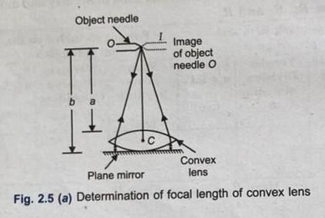
Theory:

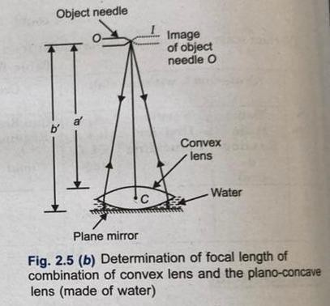

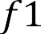
- If a convex lens of focal length f1 is placed over a few drops of water, then focal length of the plano- concave lens f formed of water is given by
1 = 1 – 1
𝐹

where F is the focal length of the combination of two lenses, i.e., convex lens plano-concave lens formed of water.

- The refractive index of water can be given as
µ = 1 + 𝑅
where R is the radius of curvature of concave surface of the plano-concave lens formed of water, i.e., it is the radius of curvature of convex surface of convex lens.
- The radius of curvature R of the convex surface of the lens is given by

R =
2
Where l is the mean distance between the two legs of the spherometer and h is the height of central screw above the plane of outer legs.

Methodology:

Determination of the focal length of the convex lens (f₁)
    - Find the rough focal length of the convex lens.
    - Take a plane mirror and clean it. Place it on the horizontal base of an iron stand fitted with a clamping arrangement.
    - Place the convex lens on the plane mirror, so that principal axis of the convex lens is along vertical.
    - Now fix the optical needle in the clamp stand and hold it horizontally above the convex lens, so that its tip lies vertically above the optical center of the lens. Adjust the height of the needle equal to rough focal length of the convex lens. By keeping the eye at a distance of about 30 cm from the needle, look for the image of the needle formed by convex lens and plane mirror.
    - Adjust the position of the needle O so that there is no parallax between the tip of the needle O and its image I.
    - Using a plumb line and metre scale, measure the distance of the tip of the needle from the center of the upper surface of the convex lens. Let it be 'a'. Now remove the convex lens and measure the distance of tip of the needle from the plane mirror. Let it be 'b'. Then focal length of the convex lens
f1 = 𝑎 + 𝑏

    - Repeat the steps 1 to 6 at least two times more and take two more observations.
    - Record all the observations in the table.

Determination of focal length of the plano-concave lens formed by water
- Pour some water whose refractive index p is to be determined over the plane mirror. Now place the convex lens over the water. Let f is the focal length of the plano-concave lens of water formed between the convex lens and the plane mirror.
- Now proceed in steps 4 to 6, to find the focal length of the combination of plano-concave lens (f) and convex lens (f1) . Let a' and b' are the distances of the upper surface of the convex lens and the plane mirror from the tip of needle then the focal length of the combination of convex lens and plano- concave lens formed of water is given by
F = 𝑎’ + 𝑏’

- Repeat the steps 9 and 10 at least two times more and take two more observations.
- Record all the observations in table.
- After determination of focal length of convex lens f1 and focal length of combination of convex lens and plano-concave lens formed by water F the focal length of plano-concave lens ƒ can be calculated as
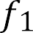
1 = 1 - 1

  - Determination of radius of curvature (R) of the surface of convex lens
- Find the pitch and least count of the spherometer.
- Raise the central screw of the spherometer and place it on the convex surface of the lens so that three legs of the spherometer rest on it.
- Now rotate the screw in downward direction till its tip just touches the convex surface of the lens. In this position the tip of the screw just touches its faint image on the surface of the lens.
- Note the reading of the circular scale, i.e., the no. of division of circular scale, which is coinciding with vertical main scale. Let this reading be a
- Now place the spherometer on a glass slab and rotate the screw in downward direction again till it just touches the surface of the glass slab. In this position the tip of the screw just touches its image the glass slab. Again note the circular scale reading in this position. Let it be 'b'.
- Taking initial circular scale reading 'a' as the reference mark, count the number of complete rotations made by circular scale between the initial and final readings a and b of the circular scale. If 'n' be the number of complete rotations made by circular scale, then the value of h is given by
ℎ = 𝑛 × 𝑝𝑖𝑡𝑐ℎ + (𝑎 − 𝑏) × 𝑙𝑒𝑎𝑠𝑡 𝑐𝑜𝑢𝑛𝑡 𝑖𝑓 𝑎 > 𝑏
and ℎ = 𝑛 × 𝑝𝑖𝑡𝑐ℎ + [(100 + 𝑎) − 𝑏] × 𝑙𝑒𝑎𝑠𝑡 𝑐𝑜𝑢𝑛𝑡 𝑖𝑓 𝑎 < 𝑏
- Repeat the steps 15 to 19 and take two more observations.
- Record all the observations in the table.
- Now press the spherometer gently on the practical notebook to get the impressions of tips of the three legs of the spherometer A, B and C. Join A, B and C to form the triangle and measure AB, BC and CA. Take the mean of AB, BC and CA which gives the mean distance 'l' between the two legs

the spherometer.

Hence,
𝑙 = 𝐴𝐵+𝐵𝐶+𝐶𝐴

Data:

OBSERVATION TABLE:
- Table for focal length of convex lens (𝑓₁):
Sr no | Upper surface of the convex lens a (cm) | Upper surface of the plane mirror b (cm) | Focal length,  𝑓 = 𝑎 + 𝑏  1 2
1 | 16 | 16.8 | 16.4
2 | 15.8 | 16.6 | 16.4
3 | 15.9 | 16.7 | 16.4

 |  | Sr | Initial Reading |  | No of complete |  | Final |  | Addition |  | h
 |  | no |  | of circular | rotations made |  | Reading of |  | division
 |  |  | scale on convex |  | by circular |  | circular |  | moved(m) |  | (cm)
 |  |  |  | lens (a) | scale (n) |  | scale on
 |  |  |  |  |  |  | glass slab
 |  |  |  |  |  |  | (b)
 | 1 |  | 65 |  | 1 |  | 0 |  | 65 |  | 0.165
Value of h = 0.165cm

(c.1) Table for focal length of convex lens formed by water (F):
 |  | Sr No. |  | Upper surface convex lens  a’ (cm) |  | Upper surface of the plane mirror b’ (cm) |  |  |  | Focal length ,  𝑎′ + 𝑏′  𝐹 =  2
 |  | 1 |  | 24.2 |  | 25 |  |  |  | 24.6
 |  | 2 |  | 24 |  | 24.8 |  |  |  | 24.6
 |  | 3 |  | 24.1 |  | 24.9 |  |  |  | 24.6
Mean value of F = 24.6cm

(c.2) Table for focal length of convex lens formed by Benzaldehyde(F):
 |  | Sr No. |  | Upper surface convex lens  a’ (cm) |  | Upper surface of the plane mirror b’ (cm) |  |  |  | Focal length ,  𝑎′ + 𝑏′  𝐹 =  2
 |  | 1 |  | 34 |  | 34.5 |  |  |  | 34.25
 |  | 2 |  | 34.2 |  | 34.7 |  |  |  | 34.25
 |  | 3 |  | 34.3 |  | 34.8 |  |  |  | 34.25
Mean value of F = 34.25

12

(c.3) Table for focal length of covnex lens formed by Parrafin Oil(F)
Sr No. | Upper surface convex lens  a’(cm) | Upper surface of the plane mirror b’ (cm) | Focal length ,  𝑎′ + 𝑏′  𝐹 =  2
1 | 27.5 | 28 | 27.75
2 | 27 | 28.5 | 27.75
3 | 27.25 | 28.25 | 27.75

Mean value of F = 27.75

Images
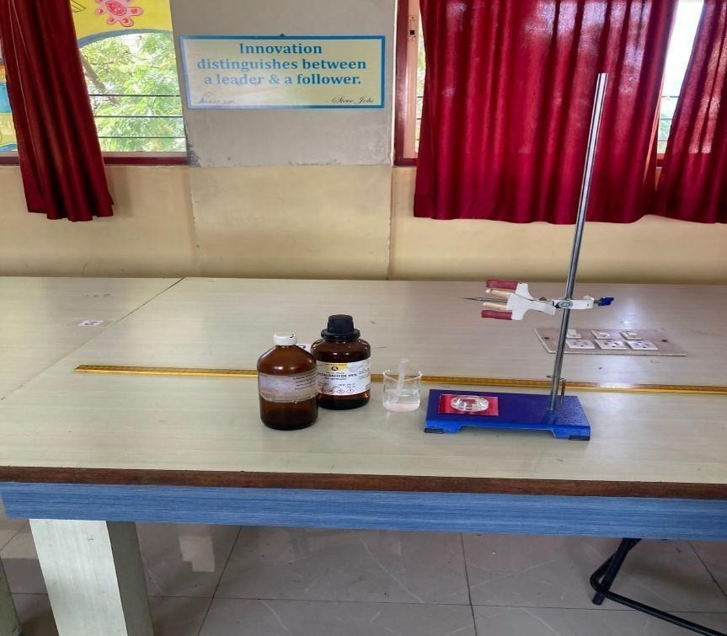
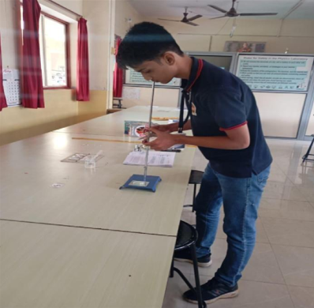
Adjusting Needle Materials

Calculations:

Mean value of 𝑓₁ = 16.4cm
Radius of curvature of convex lens, R
𝑅 = 𝑙2 + ℎ
6ℎ 2
On putting value of l and h,
R = 17.9cm

Water:

Mean value of F = 24.6cm
1 = 1 - 1 , putting value of F and 𝑓
𝑓 𝐹 𝑓1 1

We get, 𝑓 = 50cm

Refractive index, µ
= 1 + 𝑅
𝑓
= 1.3506….≈ 1.3

Benzaldehyde:

Mean value of F = 34.25cm
1 = 1 - 1 , putting value of F and 𝑓
𝑓 𝐹 𝑓1 1

We get, 𝑓 = 31.46cm

Refractive index, µ
= 1 + 𝑅
𝑓
=1.569….≈ 1.357

Paraffin oil:
Mean value of F = 27.75cm
1 = 1 - 1 , putting value of F and 𝑓
𝑓 𝐹 𝑓1 1

We get, 𝑓 = 40.10

Refractive index, µ
= 1 + 𝑅
𝑓
= 1.446….≈ 1.4

RESULT:
  - Focal Length Measurements:
    - Focal Length of the Convex Lens (in air): 16.4 cm
    - Focal Length of the Combination (for liquids):
      - Water: 24.6 cm
      - Paraffin Oil: 27.75 cm
      - Benzaldehyde: 34.25 cm
  - Radius of Curvature:
    - Radius of Curvature of the Convex Lens (R): 17.9 cm
  - Refractive Indices Calculation:
    - For Water:
      - f_{water}=49.18cm
      - Refractive Index μ_{water}=1.36

    - For Paraffin Oil:
      - fparaffin oil=40.10 cm
      - Refractive Index μ_{paraffin} _{oil} =1.45
    - For Benzaldehyde:
      - fbenzaldehyde=31.46 cm
      - Refractive Index μ_{benzaldehyde}= 1.57
  - Comparison with Real-life Values:
    - Water: Experimental value 1.361.36 vs real-life value 1.331.33 (slightly higher due to experimental conditions).
    - Paraffin Oil: Experimental value 1.451.45 vs real-life range 1.44−1.481.44 - 1.48 (matches well).
    - Benzaldehyde: Experimental value 1.571.57 vs real-life range 1.54−1.571.54 - 1.57 (accurate).

Conclusion:

In this experiment, we successfully determined the refractive indices of water, paraffin oil, and benzaldehyde using a convex lens. The values obtained for the refractive indices were close to their known real-life values, with slight variation observed for water due to potential experimental errors. The refractive indices of paraffin oil and benzaldehyde matched well with their expected values, indicating that the experimental setup and methodology were accurate for these liquids.

This study highlights the important relationship between light and materials, particularly in understanding how different substances interact with light. The use of simple optical instruments, such as the convex lens and spherometer, allowed for a precise and hands-on exploration of optical properties. The experiment also demonstrated how small deviations from expected results can occur in real-world experiments due to factors like measurement accuracy or experimental conditions.

Ultimately, this project provides valuable insight into the behavior of light as it passes through different mediums and emphasizes the importance of optical techniques in understanding the physical properties of materials.
The ability to calculate refractive indices helps in fields ranging from material science to optics, showcasing the broader relevance of the experiment beyond the classroom setting.

Glossary:
- Refractive Index (μ/mu):
A measure of how much light bends when passing through a medium. It is the ratio of the speed of light in a vacuum to the speed of light in the medium.
- Convex Lens:
A lens that is thicker at the center than at the edges, which converges light rays passing through it.
- Focal Length (f):
The distance between the center of a lens and the focal point, where parallel rays of light converge or diverge.
- Radius of Curvature (R):
The radius of the sphere from which the lens surface is a part. It is used to calculate the focal length of the lens.
- Optical Needle:
A small needle used in experiments to help locate the focal point of a lens by observing the position where the needle’s image appears sharp.
- Plane Mirror:
A flat mirror that reflects light to produce a virtual image, often used in optical experiments to reflect light through the lens.
- Refraction:
The bending of light as it passes from one medium to another with a different refractive index.
- Focal Point:
The point where light rays parallel to the principal axis converge after passing through a lens.

Bibliography:

- Fundamentals of Optics (4th ed.) - McGraw-Hill Education
- Optics (5th ed.) - Pearson Education
- University Physics with Modern Physics (13th ed.) - Pearson Education
- Fundamentals of Physics (10th ed.) - Wiley
- Refractive Index - Encyclopaedia Britannica
- The Refractive Index of Common Liquids - University of California, Berkeley
- Refraction and Focal Length of Lenses - Physics Classroom

